**ASSIGNMENT-1 INTRODUCTION TO LINUX**

**Chirag Kumar Sharma**

1. Create a directory "exercise" inside your home directory and create nested (dir1/dir2/dir3) directory structure inside "excerise" with single command.

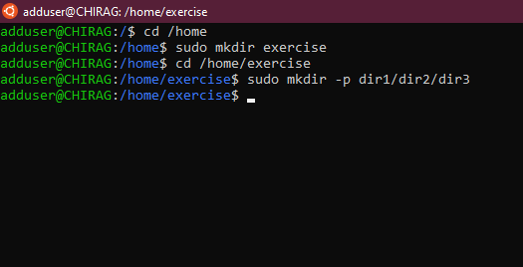

1. Create two empty files inside dir2 directory: emptyFile1, emptyFile2 in single command.

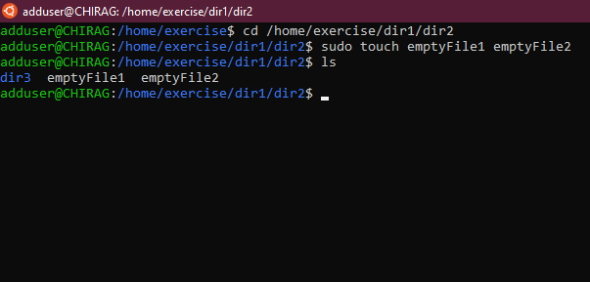

1. Create one file file1.txt containing text "hello world" and save it

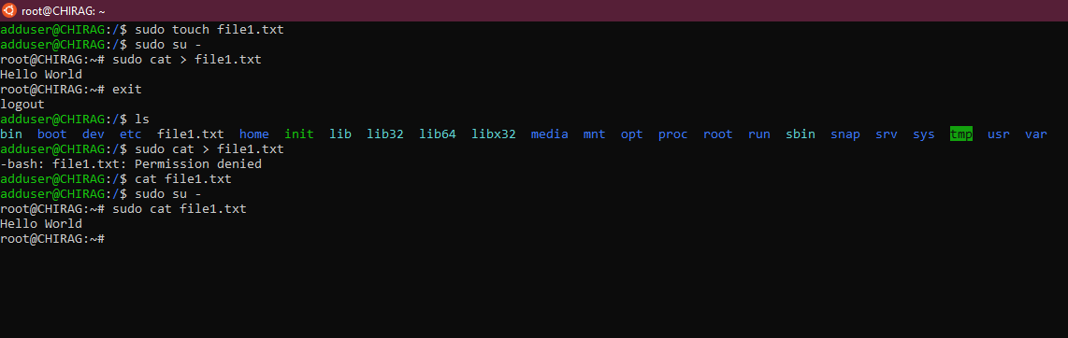

1. Find a "passwd" file using find command inside /etc. copy this files as passwd_copy and then rename this file as passwd_backup

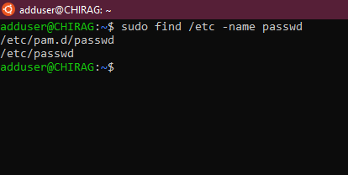

1. Create a "test" user,create its password and find out its uid and gid

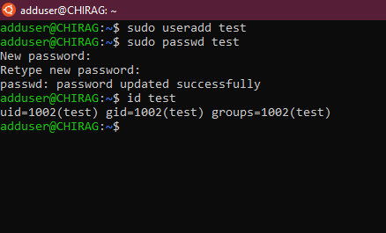

1. Change the timestamp of  emptyFile1,emptyFile2 which are exist in dir2

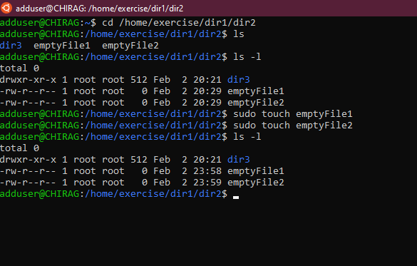

1. Create alias with your name so that it creates a file as "/tmp/aliastesting"

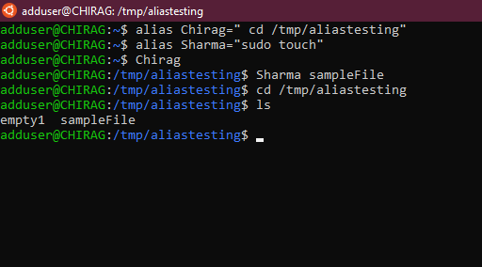

1. Install “zip” package.

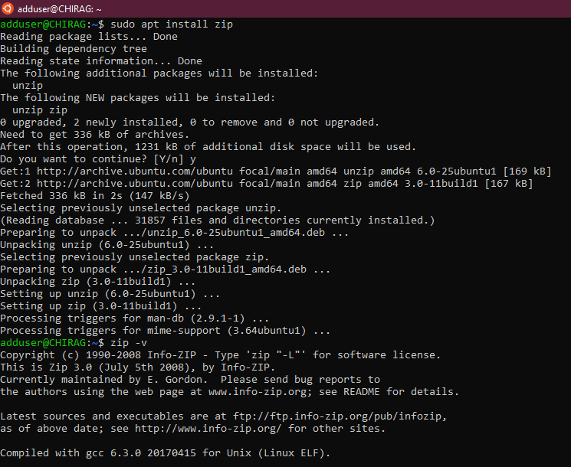

17 Download any image from web and move to desktop

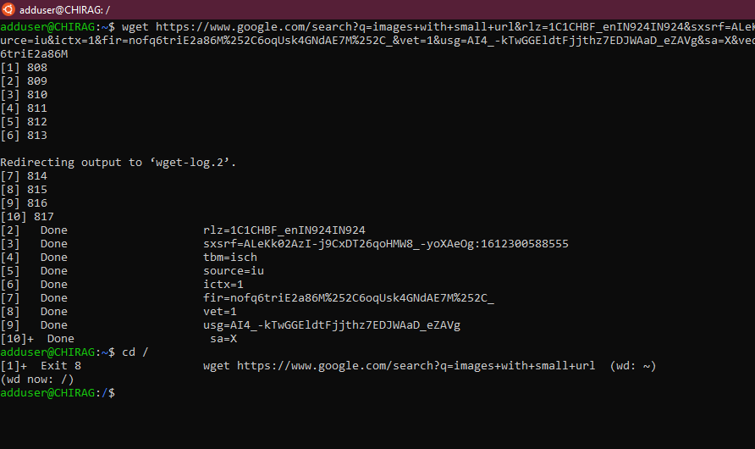

1. How to get help of commands usages

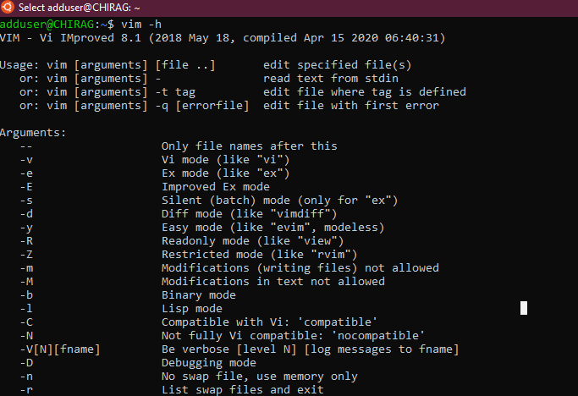

1. Create a symlink of /etc/services into /tmp/ports-info

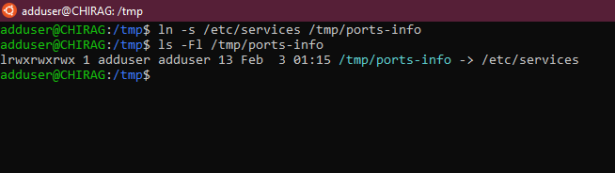

1. You are appointed as a Software/DevOps Engineer in ABC media services. On your first day you need to troubleshoot a problem. There is a command “xyz” somewhere installed in that linux system. But as a new joinee you do not have any idea about where is that Installed. How can you check that?

